SpaceVision 3000
o ' .
* |
* . --o--
. |
o '
_____________
==c(___(o(____(_()
\=\
)=\
//|\\
//|| \\
// || \\
// || \\
// \\
User Manual

Overview
Welcome to SpaceVision 3000, a one-of-a-kind compact device that shows real-time space imagery and information from NASA and other online sources. It cycles through astronomy pictures, rocket launches, exoplanets, Earth views, and solar observations.
POWER UP: SV3K has a LiPo battery installed. A red LED inside the case indicates the battery has juice. Turn SV3K on with the small slider switch on the top left of the green circuit board. If the red LED is off, it is time to recharge. Plug a USB-C cable into the back port. Blue LED indicates charging. When it turns off it is fully charged and should last a couple days (if left on all the time).

Connectivity
SpaceVision 3000 requires an internet connection. When you boot up for the first time, you’ll see a brief instructions page. SV3K will create a Wifi access point named: SpaceVIsion3000
Find it in your list of wifi connections on your phone or computer. Log in to it with password: marvin42
Then it will direct you to a simple webpage where you can input your home internet SSID and password. After a successful connection it will start downloading images and data.
SV3K will store your login info for the next time. If you take it to work or anywhere else you will need to set the credentials via the access point again. Total portability!
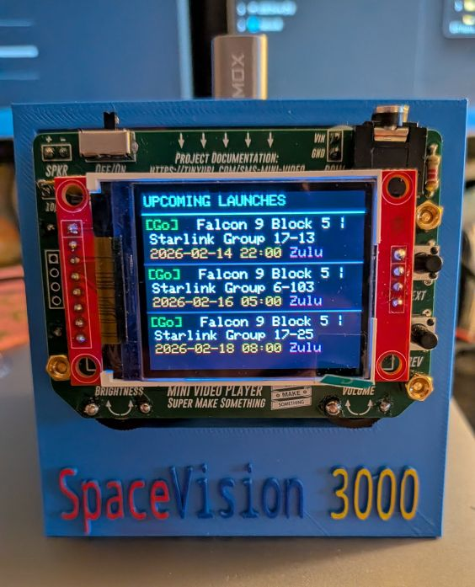
Layout
Power switch
Brightness control
Button NEXT
Button PREV
Volume control (not used)
Audio out jack (not used)

What does it do?
SV3K has 5 different modes. Cycle to the next mode with the NEXT (upper) button, and display relevant data with the PREV (lower) button).
1. Astronomy Picture of the Day (APOD)
- What it shows: NASA's featured space image for today
- Updates: Daily (automatically checks for a refresh every 2 hours)
- Note: If APOD is a video, you'll see a thumbnail instead
2. Upcoming Launches
- What it shows: Next 3 rocket launches worldwide
- Information displayed:
  - Launch number and status ([Go], [TBD], etc.)
  - Mission name (up to 2 lines)
  - Launch date and time
- Status colors:
  - Green = Go for launch
  - Yellow = To Be Determined
- Updates: Every 2 hours, or press PREV to refresh
3. Recent Exoplanets
- What it shows: 3 most recent exoplanets discovered (based on publication date of discovery)
- Information displayed:
  - Exoplanet name
  - Discovery year | Method used
  - Star name, distance from Earth in light years (<100: green, 100-500: cyan, 500+: orange)
Updates: On startup, or press PREV to refresh
4. Static Earth View
- What it shows: Single view of Earth from DSCOVR satellite
- Location: L1 Lagrange point (shows actual current distance of satellite)
- Metadata (press PREV):
  - Current entry in the Guide
  - Date/time of image
  - Distance from Earth
  - Credit: "via NASA EPIC/DSCOVR"
  - Blank view (just the image)
5. Earth Multi-view
- What it shows: Rotating views of Earth (8-13 frames)
- Display: "EPIC/DSCOVR View X/Y" at bottom
- Manual control: Press PREV to advance frames. Press NEXT to skip to Sun Views
6. Sun Views (5 wavelengths)
- What it shows: Different views of the Sun from Solar Dynamics Observatory
- Wavelengths:
  - AIA 171Å Corona (coronal loops)
  - HMI Continuum (visible light surface)
  - AIA 335Å Active (active regions)
  - AIA 94Å Flares (flaring regions)
  - HMI Magnetogram (magnetic field)
- Metadata (press PREV):
  - Wavelength name
  - Current date/time
  - Blank view

Button Controls
NEXT button (top button)- Cycle Through Views
Press to advance to the next display mode in this order:
- 1. APOD → 2. Upcoming missions → 3. Most recent exoplanet discoveries → 4. Static Earth → 5. Earth Multi-view → 6. Sun Views → back to APOD
- Press to escape screensaver (moves to next display from where you stopped)
PREV button (lower button) - View Details / Actions
- APOD mode: Cycles through date, title, blank
- On Launches: Refreshes launch data
- On Exoplanets: Refresh exoplanet data
- On Static Earth: Cycles through Guide entry, date, distance, credit, blank
- On Earth Multi-view: Manually advances to next frame
- On Sun Views: Cycles through blank, date, and wavelength name
- On screensaver, returns to APOD

Technical Details
Data Sources
- APOD: NASA APOD API
- Earth images: NASA EPIC (Earth Polychromatic Imaging Camera)
- Sun images: NASA Solar Dynamics Observatory (SDO)
- Launch data: TheSpaceDevs Launch Library API
- Exoplanet data: NASA Exoplanet Archive
Update Schedule
- Auto-refreshes every 2 hours
- Launch data can be manually refreshed with PREV (up to 15 times per hours)
- APOD updates daily at midnight UTC
Display Specifications
- Screen: ST7735 160x128 pixels
- Microcontroller: ESP32 WROOM
- Connection: WiFi required for image downloads
- Image resize proxy: images.weserv.nl
Network Requirements
- WiFi connection required
- API keys configured for NASA services
- Internet access for image downloads

Troubleshooting
"Connecting to WiFi..." stuck
- Check WiFi credentials in code
- Ensure WiFi network is available
- Restart device
"Download failed!" message
- Check internet connection
- Verify API key is valid
- Wait a moment and let auto-refresh retry
"Memory error!" message
- Restart device
- Image may be too large (rare with current resize settings)
No launch data
- Press PREV to refresh
- API may be temporarily unavailable (free version only allows 15 updates/hour)
- Check serial monitor for error codes (if plugged into USB with Arduino IDE)
Blank/corrupted images
- May indicate network timeout
- Wait for auto-refresh (2 hours)
- Check serial monitor for JPEG decode errors

Screensavers
After 5 minutes of no button presses the screensavers will start.
Screensaver A is a rogue black hole cruising through open space, happily warping spacetime and gravity lensing stars as it goes.
Screensaver B is a starfall that gradually consumes whatever image was left up on the screen until all that is left is the infinite trails of stellar pathways…
Press any key to exit! NEXT goes to next screen, PREV goes back to APOD.

Power & Reset
- Power on: Power switch is on top left of the screen, for battery power. Can also be powered via USB on the back port, which also charges the battery. Top USB also provides power, but is mainly to update/change the sketch loaded on the ESP32.
- Reset: Cycle power switch off/on.
- First boot: Takes ~30 seconds for Marvin’s brain to download all initial data

Serial Monitor (for debugging)
Requires the Arduino IDE (free download). Connect to serial monitor at 115200 baud to see:
- WiFi connection status
- API response codes
- Download progress
- Image sizes and decode results
- Current view mode changes

Credits
Data Sources:
- NASA APOD API
- NASA EPIC/DSCOVR
- NASA SDO (Solar Dynamics Observatory)
- TheSpaceDevs Launch Library 2 API
- AI tools were used in the creation of the code!
Image Processing:
- images.weserv.nl resize proxy
Hardware:
- ESP32 development board
- ST7735 160x128 TFT display

